

Motorola AURA

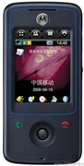
Description

Motorola AURA is a luxury handset that not only looks unique, but is manufactured uniquely as well - with high-end materials. It has anodized aluminum buttons, stainless steel with chemically etched textures, grade 1 sapphire crystal over the display.

STORE PRICE: Rs 106,731 /-
ONLINE PRICE: Rs 100,962 /-

Brand : Motorola
Model Name : Aura
Released Year : 2008
Phone Memory : 8MB Internal Memory, 2 GB
External Memory : No
Colors : Silver
Form : Twist
Dimensions : 96.9 x 47.6 x 18.6 mm
Weight : 141 g

